|  |  |
| --- | --- |
| Assignment Date | 19.09.2022 |
| Student Name | S.Jayanthi |
| Student Roll Number | 962719106011 |
| Maximum Marks |  |

**Question 1:** **Download the dataset:**

**solution:**

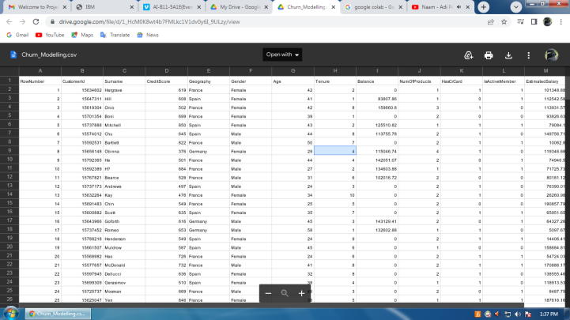

**Question 2: Load the dataset**.

**solution:**

import numpy as np

import pandas as pd

df=pd.read_csv("/content/Churn_Modelling.csv")

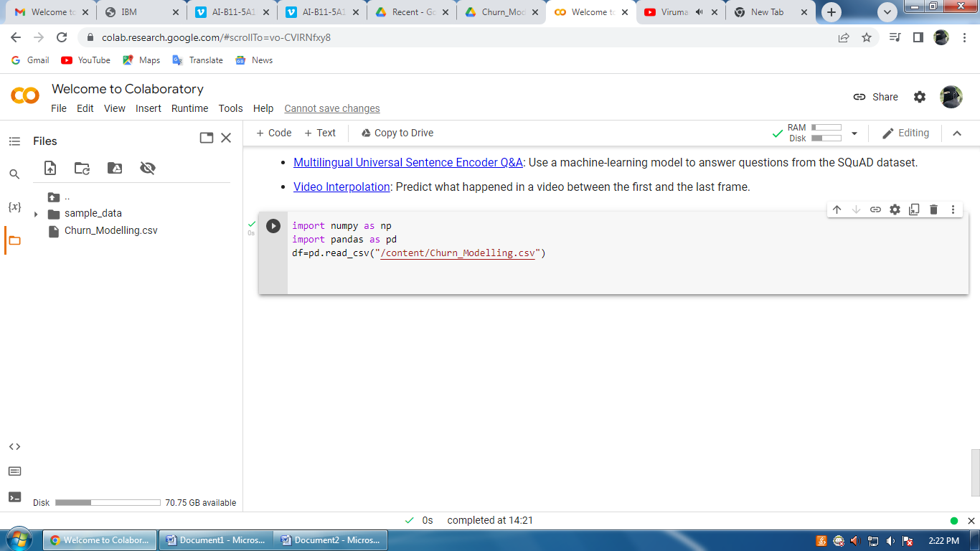

**Question 3. Perform Below Visualizations.**

**● Univariate Analysis**

**solution:**

sns.histplot(df.EstimatedSalary,kde=True)

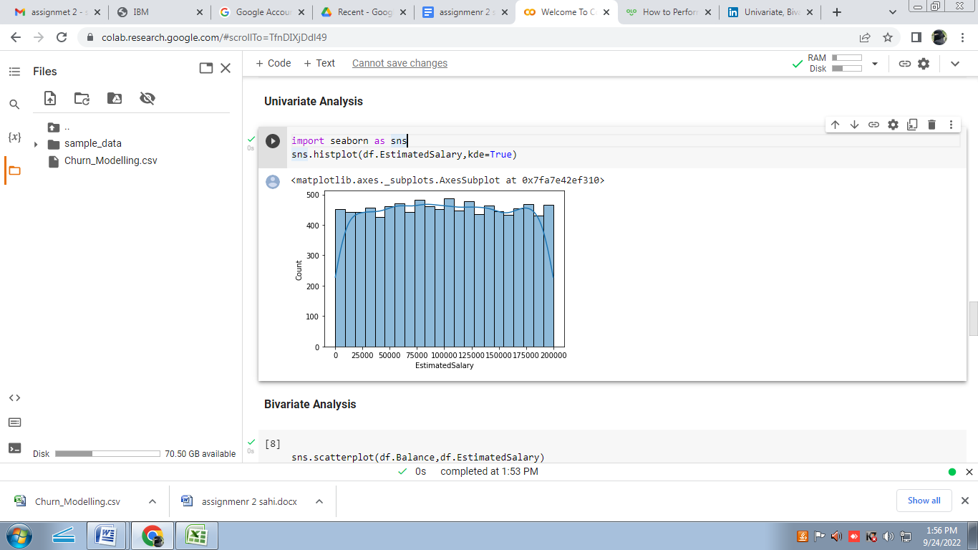

**● Bi - Variate Analysis**

**solution:**

sns.scatterplot(df.Balance,df.EstimatedSalary)

plt.ylim(0,15000)

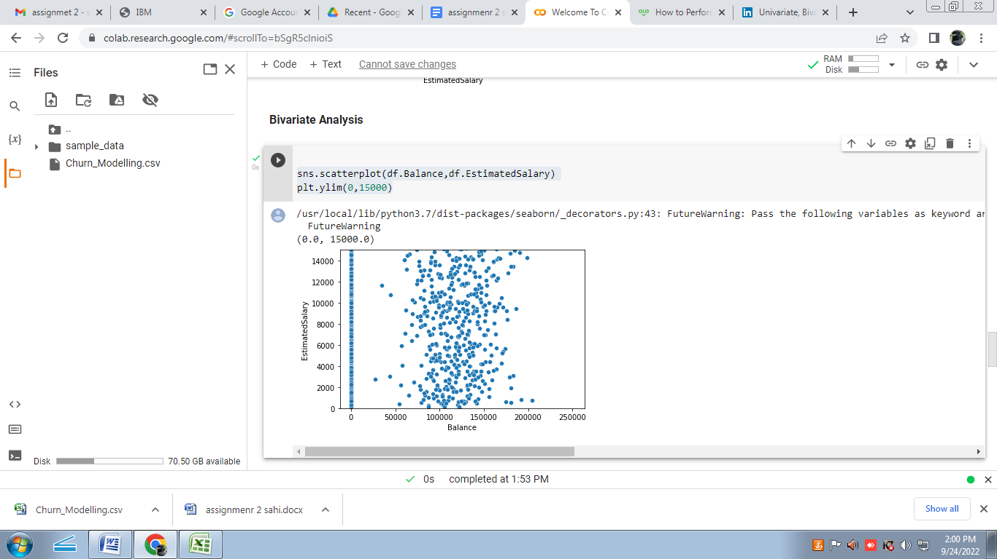

**● Multi - Variate Analysis**

**solution:**

df=pd.read_csv("/content/Churn_Modelling.csv")

sns.pairplot(df)

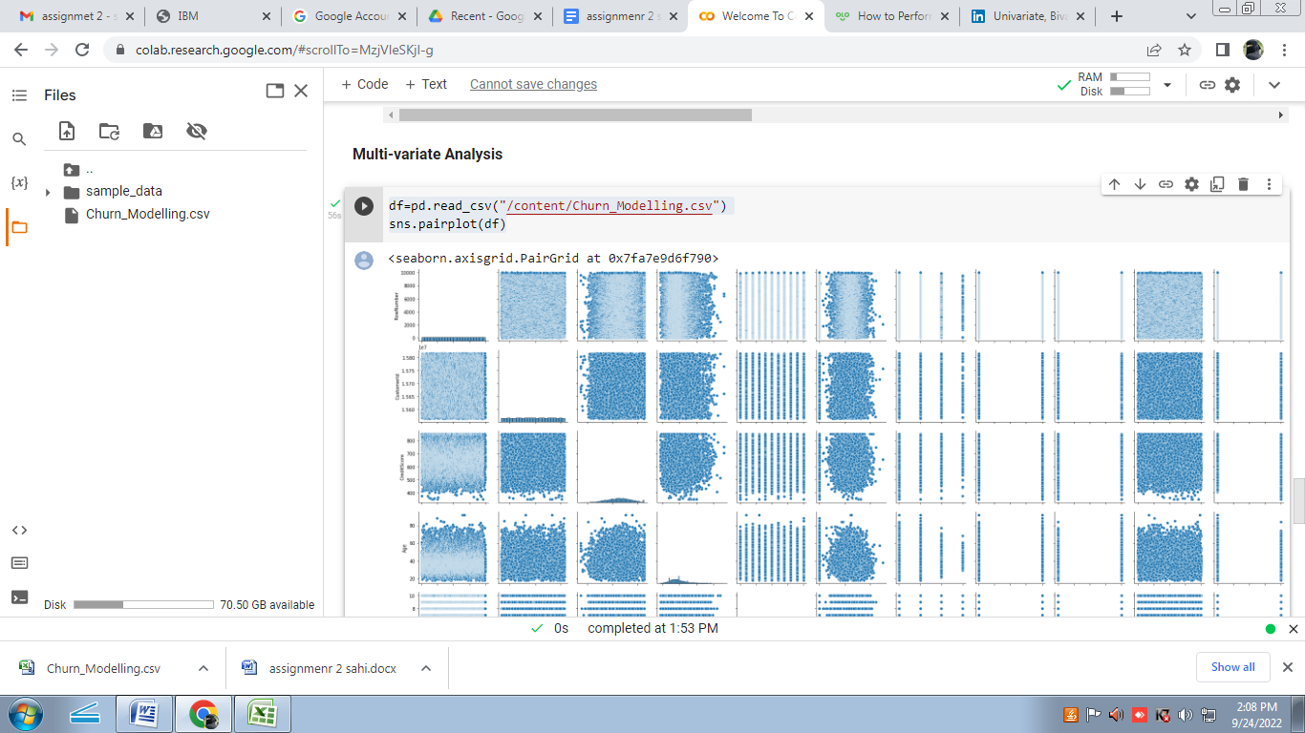

**Question 4. Perform descriptive statistics on the dataset.**

**solution:**

df=pd.read_csv("/content/Churn_Modelling.csv")

df.describe(include='all')

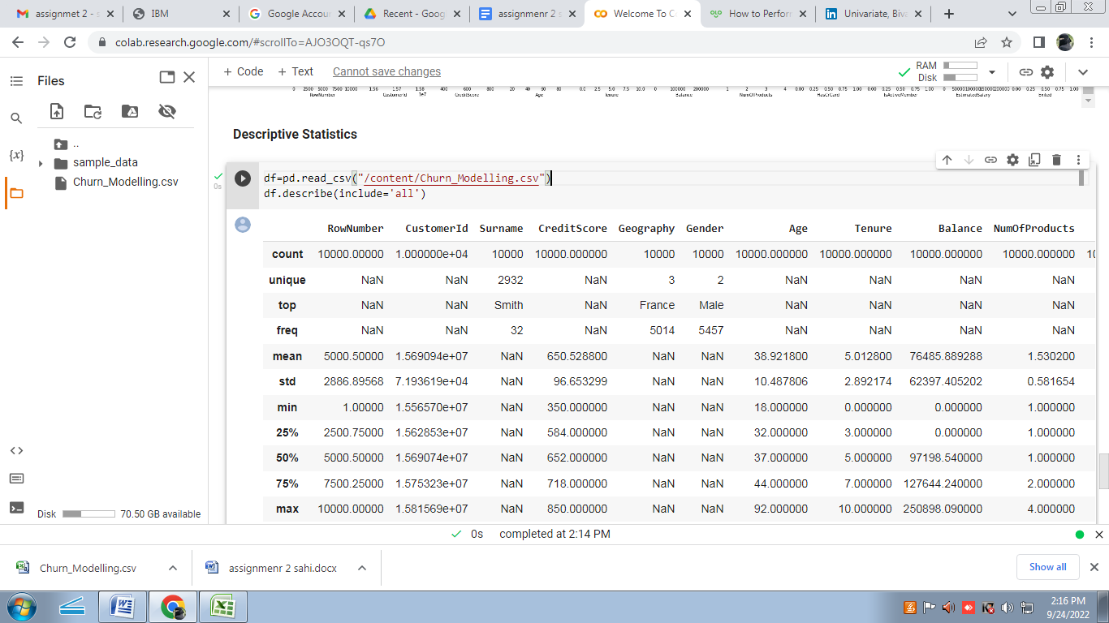

**Question 5 : Handle the Missing values**.

**solution:**

from ast import increment_lineno

import pandas as pd

import numpy as np

import seaborn as sns

import matplotlib.pyplot as plt

%matplotlib inline

sns.set(color_codes=True)

df=pd.read_csv("/content/Churn_Modelling.csv")

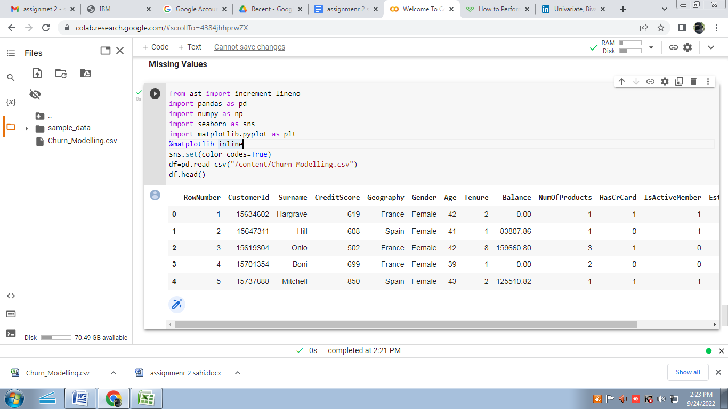 df.head()

**Question 6. Find the outliers and replace the outliers**

**solution:**

import pandas as pd

import matplotlib

from matplotlib import pyplot as pyplot

%matplotlib inline

matplotlib.rcParams['figure.figsize']=(10,6)

df=pd.read_csv("/content/Churn_Modelling.csv")

df.sample(5)

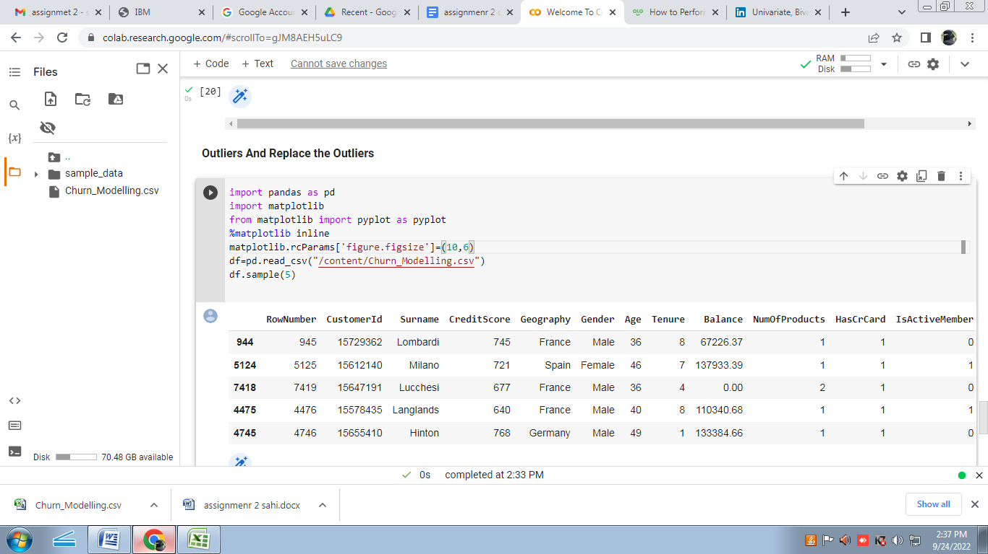

**Question 7. Check for Categorical columns and perform encoding.**

**solution:**

df=pd.read_csv("/content/Churn_Modelling.csv")

df.columns

import pandas as pd

import numpy as np

headers=['Rownumber','CustomerID','Surname','CreditScore',

'Geography','Gender','Age','Tenure','Balance','NumofProducts',

          'HasCard','IsActiveMember','EstimatedSalary','Exited']

import seaborn as sns

df.head()

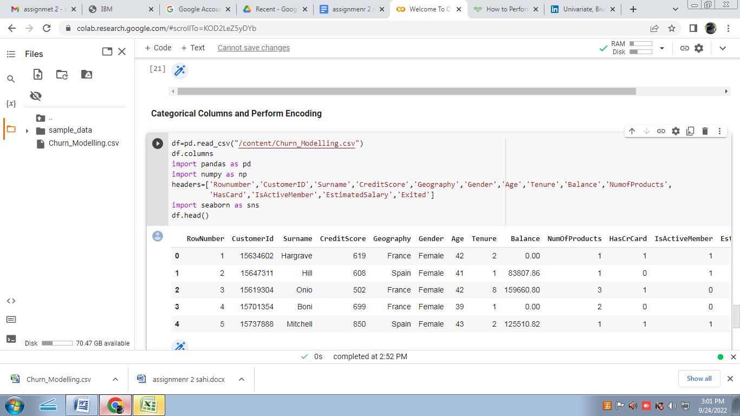

**Question 8 .Split the data into dependent and independent variables.**

**solution :**

x=df.iloc[:,:-1].values

print(x)

y=df.iloc[:,-1]._values

print(y)

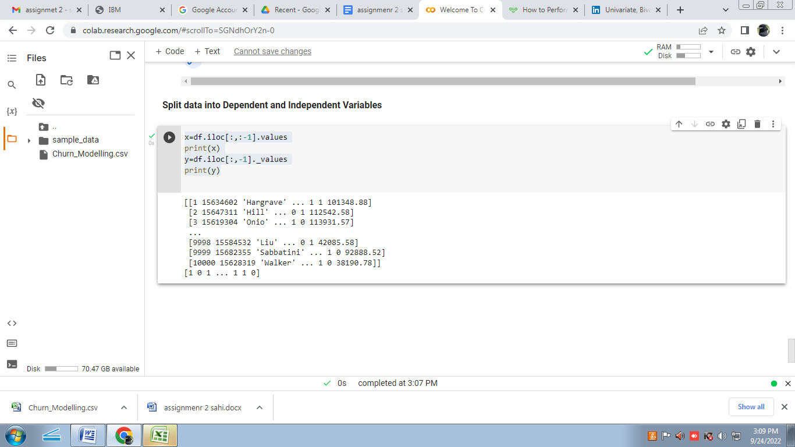

**Question 9. Scale the independent variables**

**solution:**

import seaborn as sns

df=pd.read_csv("/content/Churn_Modelling.csv")

dff=df[['Balance','Age']]

sns.heatmap(dff.corr(),annot=True)

sns.set(rc={'figure.figsize':(40,40)})

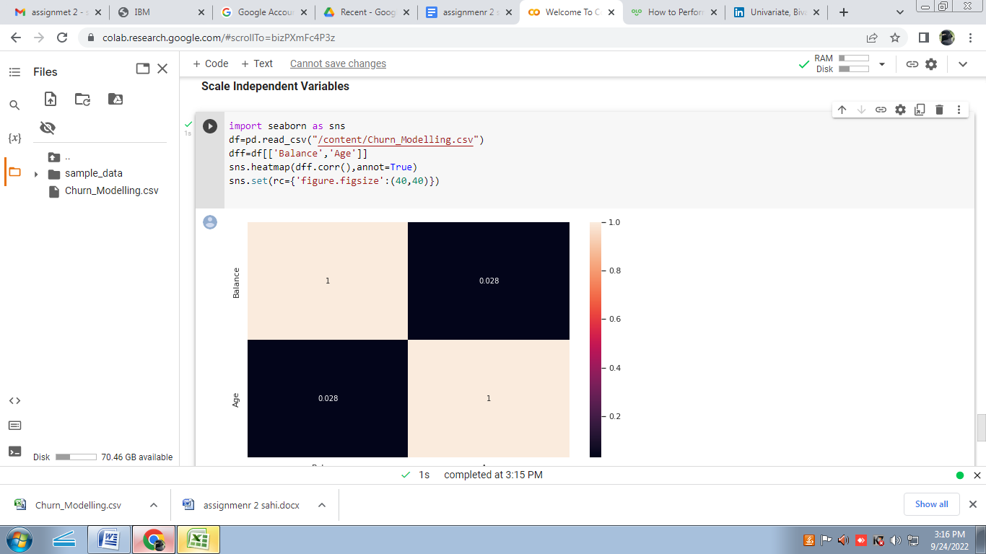

**Question 10. Split the data into training and testing**

**solution:**

from scipy.sparse.construct import random

x=df.iloc[:,1:2].values

y=df.iloc[:,2].values

from sklearn.model_selection import train_test_split

x_train,x_test,y_train,y_test=train_test_split

(x,y,test_size=0.2,random_state=0)

print('Row count of x_train table'+'-'+str(f"{len(x_train):,}"))

print('Row count of y_train table'+'-'+str(f"{len(y_train):,}"))

print('Row count of x_test table'+'-'+str(f"{len(x_test):,}"))

print('Row count of y_test table'+'-'+str(f"{len(y_test):,}"))

